Q1
#include "mpi.h"
#include <stdio.h>

int power(int base, int exponent)
{
if (base == 0 || base == 1)
return base;
else if (exponent == 0)
return 1;
else if (exponent == 1)
return base;
else
return base * power(base, exponent - 1);
}

int main(int argc, char *argv[])
{
int rank, size;

MPI_Init(&argc, &argv);
MPI_Comm_rank(MPI_COMM_WORLD, &rank);
MPI_Comm_size(MPI_COMM_WORLD, &size);

int x = 10;
printf("x = %d => pow(x,%d) is %d \n", x, rank, power(x, rank));

MPI_Finalize();
return 0;
}

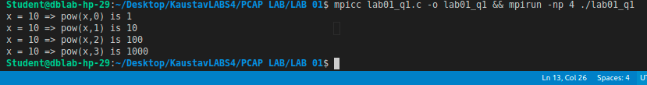

Q2
#include "mpi.h"
#include <stdio.h>

int main(int argc, char *argv[])
{
int rank, size;

MPI_Init(&argc, &argv);
MPI_Comm_rank(MPI_COMM_WORLD, &rank);
MPI_Comm_size(MPI_COMM_WORLD, &size);

if (rank % 2 == 0)
printf("Hello (Rank %d) \n", rank);
else
printf("World (Rank %d) \n", rank);

MPI_Finalize();
return 0;
}
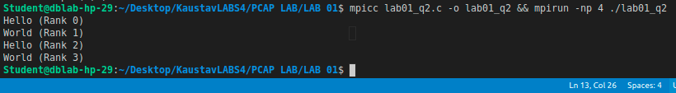

Q3
#include "mpi.h"
#include <stdio.h>

int main(int argc, char *argv[])
{
int rank, size;

const int num1 = 10;
const int num2 = 20;

MPI_Init(&argc, &argv);
MPI_Comm_rank(MPI_COMM_WORLD, &rank);
MPI_Comm_size(MPI_COMM_WORLD, &size);

int result = 0;
switch (rank)
{
case 0:
result = num1 + num2;
printf("%d + %d is %d (Rank %d) \n", num1, num2, (num1 + num2), rank);
break;
case 1:
result = num1 - num2;
printf("%d - %d is %d (Rank %d) \n", num1, num2, (num1 - num2), rank);
break;
case 2:
result = num1 * num2;
printf("%d * %d is %d (Rank %d) \n", num1, num2, (num1 * num2), rank);
break;
case 3:
result = num1 / num2;
printf("%d / %d is %d (Rank %d) \n", num1, num2, (num1 / num2), rank);
break;
}

MPI_Finalize();
return 0;
}

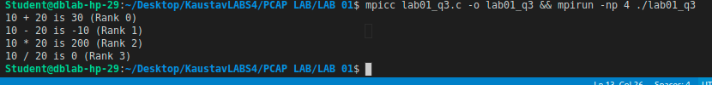

Q4
#include "mpi.h"
#include <stdio.h>

int main(int argc, char *argv[])
{
int rank, size;

char str[] = "HeLLO";

MPI_Init(&argc, &argv);
MPI_Comm_rank(MPI_COMM_WORLD, &rank);
MPI_Comm_size(MPI_COMM_WORLD, &size);

if (str[rank] >= 'a' && str[rank] <= 'z')
str[rank] = str[rank] - 32;
else if (str[rank] >= 'A' && str[rank] <= 'Z')
str[rank] = str[rank] + 32;

printf("My rank is %d and the modified string is %s \n", rank, str);

MPI_Finalize();
return 0;
}

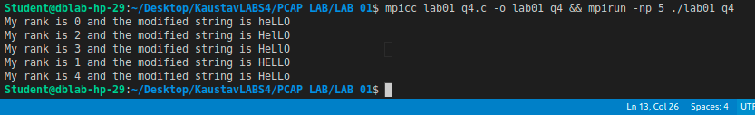

Q1 Additional Exercise
#include "mpi.h"
#include <stdio.h>
#include <stdbool.h>

int reverse_digits(int num)
{
int rev = 0;

while (num > 0)
{
int last = num % 10;
rev = rev * 10 + last;
num = num / 10;
}

return rev;
}

int main(int argc, char *argv[])
{
int rank, size;

MPI_Init(&argc, &argv);
MPI_Comm_rank(MPI_COMM_WORLD, &rank);
MPI_Comm_size(MPI_COMM_WORLD, &size);

int input[] = {18, 523, 301, 1234, 2, 14, 108, 150, 1928};

switch (rank)
{
case 0:
case 1:
case 2:
case 3:
case 4:
case 5:
case 6:
case 7:
case 8:
printf("after reversing %d , we get %d (Rank %d) \n", input[rank], reverse_digits(input[rank]), rank);
break;

default:
break;
}

MPI_Finalize();
return 0;
}
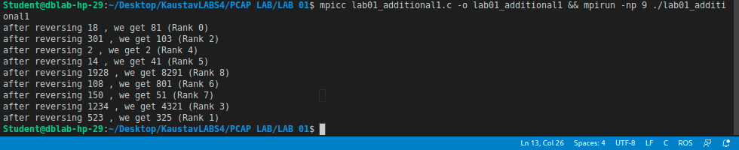

Q2 Additional Exercise

#include "mpi.h"
#include <stdio.h>
#include <stdbool.h>

bool isPrime(int num)
{
if (num < 2)
return false;

for (int i = 2; i < num; i++)
{
if (num % i == 0)
return false;
}

return true;
}

int main(int argc, char *argv[])
{
int rank, size;

MPI_Init(&argc, &argv);
MPI_Comm_rank(MPI_COMM_WORLD, &rank);
MPI_Comm_size(MPI_COMM_WORLD, &size);

if (rank == 0)
{
for (int i = 1; i < 50; i++)
{
if (isPrime(i))
printf("Prime number %d (Rank %d ) \n", i, rank);
}
}
else
{
for (int i = 51; i < 101; i++)
{
if (isPrime(i))
printf("Prime number %d (Rank %d ) \n", i, rank);
}
}

MPI_Finalize();
return 0;
}
